MCSA 2022-2023 SEASON GUIDE
Welcome to the Midwestern Collegiate Ski Association! As we enter our fourth competitive season, we are excited to have your Nordic Club compete with us, and we are looking forward to expanding and strengthening the Midwestern skiing community with you.
This Guide contains important information about 2022-2023 season, with details on:
- The MCSA Nordic Charter / Bylaws
- Midwest Collegiate Cup Schedule and Scoring
- The MCSA Regional Championships
- Registration and Fees
- Discounts and Sponsorships
If you have any questions, concerns, or just need clarification, please contact:
- MCSA Nordic Student Representative and Nordic Assembly President: Emma Reineke: reine368@umn.edu
- MCSA Nordic Commissioner: Luke Dykowski: lukedykowski@gmail.com
- MCSA Nordic Coordinator: Ted Theyerl: TheyerlT@uwstout.edu
- MCSA Conference Coordinator: Robin Dzubay: robin@uscsa.org
General information about the MCSA can be found here:
https://www.skimcsa.com/ .
General information about our national governing body, the USCSA, can be found here:
https://www.uscsa.org .

- MCSA Nordic Charter / Bylaws
Prior to our 2021-22 season, our founding Clubs met to approve a new Charter, which continues to govern our operations, structures, and decision-making.
Article V of the Charter is of greatest relevance to our new and returning Clubs. It establishes our decision-making body, the Midwestern Nordic Assembly, in which all MCSA-registered Clubs are entitled to participate. For Clubs returning this 2022-23 season, or for new members, we encourage you to familiarize yourself with our Charter and bylaws, all of which are available on the MCSA website.
- Midwest Collegiate Cup: Schedule and Scoring
MCSA Nordic continues to have two categories of scored competition – a cumulative, World-Cup style racing circuit (the Midwest Collegiate Cup) and an MCSA Regional Championships event.
The Collegiate Cup scores Clubs against one another at popular citizen races; much like the International Biathlon Union World Cup, the Collegiate Cup includes the MCSA Regional Championships in its cumulative scoring totals.
Meanwhile, the MCSA Regional Championships are an MCSA-only event which will determine which MCSA Clubs qualify to attend the USCSA National Championships in March.
Please note that Clubs are divided into Men’s and Women’s teams for scoring purposes.
The 2022-23 Midwest Collegiate Cup will aggregate team scores from:
- The Half-Noquemanon (24k classic and skate): Marquette MI, January 28th, 2023
- The Mt. Ashwabay Summit Race (25k skiathlon): Bayfield WI, February 4th, 2023
- The Vasaloppet USA (Dala skate, and Vasaloppet skate): Mora MN, February 11th, 2023
- The MCSA Regional Championships (5k classic / 10k skate): Rhinelander WI, February 18th-19th, 2023
- The American Birkebeiner (55k classic and 50k skate): Hayward WI: February 25th, 2023
Team scores for the Midwest Collegiate Cup are calculated using the Mathie-Halvorson system. A model of the Mathie-Halvorson system can be found at the end of this document in Appendix 1. Only USCSA-registered skiers can score for your team, and you will be required to provide a roster of your skiers before each race.
Remember: because the Collegiate Cup is a cumulative circuit, our scoring system does not require you to attend every race! Compete when you can, and field what athletes you have available / interested – your Club can score towards the Cup with even a single racer.
The MCSA will provide awards for the top 3 teams at the end of the Collegiate Cup. As in 2022, we will host the Collegiate Cup awards ceremony on the Main Street Podium on Birkie Saturday!
Note that you will be required to submit rosters of your attending skiers before our scheduled races. Failure to submit a complete roster will prevent your team from scoring.
- MCSA Regional Championships
The MCSA Regional Championships are scheduled for the weekend of February 18th, 2023, at the CAVOC in Rhinelander, WI. This will be a two-day event, with the 5k classic and 10k skate influenced by the USCSA National Championships race format for 2023. Only USCSA-registered individuals are allowed to compete at Regionals. The top five Men’s and Women’s teams at the MCSA Regional Championships will qualify to represent the Midwest at the USCSA National Championships in Mammoth, CA.
You can see coverage of our 2022 Regional Championships here: https://www.skinnyski.com/racing/college/2022/mcsa02-21.pdf. The folks up in Rhinelander were spectacular hosts in 2020 and 2022, and we can’t wait to race with them in the coming season!
PLEASE NOTE: as in 2021-22, the MCSA Regional Championships will include two tracks of scoring.
The first track will consider the MCSA Regional Championships a part of the broader Midwest Collegiate Cup. This first track will score all participating, USCSA-registered skiers using the Mathie-Halvorson System, and will factor these scores into the Midwest Collegiate Cup standings. These scores will have no bearing on MCSA Regional Championship awards, nor will they affect qualification for the USCSA National Championships.
The second track will consider the MCSA Regional Championships a standalone event. The results from the MCSA Regional Championships scored on this second track alone will determine which teams are crowned our 2022-23 Regional Champions, which skiers and teams win awards and medals, and which teams qualify to attend the USCSA National Championships. Before scoring on this second track, a skier must have participated in at least TWO ‘regular season’ competitions. Skiers who have not met this participation requirement will still have their results factored into the Midwest Collegiate Cup standings; however, they will not be eligible for MCSA Regional Championship awards; their results will not affect their teams’ rankings in the standalone MCSA Regional Championship, and will not influence their teams’ qualification for the USCSA National Championships.
All Midwest Collegiate Cup races other than the MCSA Regional Championships are classified as ‘regular season’ competitions (however, because the American Birkebeiner is after the MCSA Regional Championships, attending the Birkie will not count towards a skier’s two-race participation threshold). In addition to these Midwest Collegiate Cup races, the MCSA has designated two ‘regular season’ competitions – participation in which will count towards a skier’s two-race threshold. These additional races are:
- The Michigan Tech Pre-Nationals CXC Cup: Houghton MI, December 17th-18th, 2022
- The Full Noquemanon (50k classic and skate): Marquette MI, January 28th, 2023
This should enable skiers who may be unable to attend an adequate number of Midwest Collegiate Cup races to score towards awards, trophies, and USCSA National Championships qualification at the MCSA Regional Championships. Please note that the additional regular-season races designated above do not count towards standings in the Midwest Collegiate Cup.
You can consult the diagram below for an easy summary of our schedule and its requirements this season:
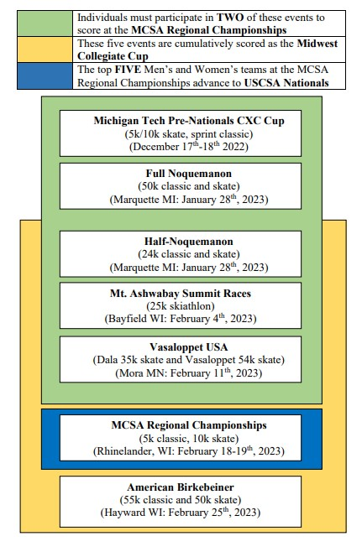

- Registration and Fees
The USCSA/MCSA has membership fees at the Club level and the individual level. Any skier who wishes to compete and score in the MCSA must be individually registered with the USCSA, in addition to being a member of a USCSA-registered Club. Registration is open now.
Individual Fees:
- Are $20.00 per individual before November 1st, 2022. Register here: https://www.uscsa.org/memberregistration.html.
- Once an individual is registered with your Club, they must be approved by your institution’s Registrar as academically eligible to compete.
Club Fees: USCSA:
- At the USCSA level, fees are $175 per institution (i.e. “The University of Minnesota, Twin Cities) + $175 per team (“UMNTC Nordic Women”, “UMNTC Nordic Men”) before November 1st. For up-to-date pricing, visit and to register, click here: https://www.uscsa.org/memberregistration.html. Even those Clubs with a single administrative structure, who do not internally distinguish between Men’s and Women’s teams, will need to register separate teams if they plan to field male and female skiers. This is for scoring and awards purposes, and has no impact on schedules or race distances.
- For new institutions and new Clubs these fees are completely waivable for your first season with the USCSA. Contact registration@uscsa.org to obtain such a waiver.
- For teams with fewer than 3 members, the team fee is only $87.50 before November 1st.
- For Clubs who do not receive a waiver, the institution fee can be split between your Club and any other USCSA Clubs your institution fields (Alpine, Snowboard). You will need to communicate with your institution’s USCSA-affiliated Clubs to coordinate this fee-splitting.
Club Fees: MCSA:
- At the MCSA level, fees are $10 per USCSA-registered individual on your Club, to a maximum of 15 individuals.
- This means the most your Club will pay is $150 in MCSA fees.
- These fees pay for our trophies, awards, and contribute toward building our Nordic infrastructure.
- Please complete fee payment (or make arrangements for payment method with Robin Dzubay) by December 16th, 2022.
  - Robin can process check, card, or Venmo (@Robin-Dzubay). You can email her at robin@uscsa.org .
- Discounts and Opportunities
Skiers who are individually-registered USCSA members, competing on USCSA-registered Clubs, are eligible for a variety of unique discounts and opportunities. Please note that skiers who are not individually-registered USCSA members are not eligible for any of the discounts or opportunities above, even if they are members of USCSA-registered Clubs.
USCSA-registered individuals are entitled to the following discounts and sponsorships:
- 40% off all Swix and Toko products (wax, gear, etc.)
- 40% off all Atomic Nordic equipment (skis, boots, etc.)
- 40%-50% bulk/team order discounts with Skratch Nutrition
- Fixed, minimal-cost registration fees at:
  - The Half-Noquemanon (approx. 50% discount)
  - Mt. Ashwabay Summit (approx. 30% discount)
  - Vasaloppet USA events (approx. 50% discount)
  - Details on these Midwest race discounts will be provided to USCSA-registered members through the MCSA Nordic Student Representative
- A wide range of apparel, gear, and snowsport discounts through various retailers and brands. You can see the full list by visiting the USCSA’s Member Benefits page.
...so, a pretty big bang for your buck! Note that your USCSA-registered Club can also use these discounts to provide customized, Club-branded gear to your skiers.
Additionally, remember that your individual USCSA registration makes you eligible to:
- Win MCSA-specific awards
- Score at MCSA events towards the Midwest Collegiate Cup
- Compete at the MCSA Regional Championships
- Qualify for USCSA Nationals

We hope this clarifies any questions you may have about the 2022-23 MCSA Nordic competitive season. For further details, please reach out to the contacts listed at the top of this Guide, or visit https://www.skimcsa.com/ .

APPENDIX 1: Explaining the Mathie-Halvorson Scoring System:
The sheets below demonstrate the Mathie-Halvorson Scoring System. You do not need to understand how Mathie-Halvorson operates – that’s the MCSA’s job. This is just to answer any questions you may have about our Midwest Collegiate Cup scoring. We have used this system effectively since its inception in 2019.
REMEMBER:
- Mathie-Halvorson Scoring is only used for our Midwest Collegiate Cup races.
- The winner of any race receives 50 points. Points back from 50 are determined by the size of the MCSA field at an event. All finishers receive at least 1 point.
- At a given event, the top 5 racer scores from each team are added to calculate the Team Score. Teams can score with as few as 1 racer. In races with more than one discipline, the top 5 racer scores do not inherently correspond to the top 5 racer finishing positions.
- Team Scores are added to determine final Midwest Collegiate Cup standings. The MCSA will provide awards for the top 3 Men’s and Women’s Teams on Birkie Saturday.
The Mathie-Halvorson System:
Below is the scoring system itself.
- The orange column demonstrates the points assigned to a field size of 30 or more skiers. This number is fixed.
- The yellow column calculates the points assigned to a field of less than 30 skiers. Play around with the bolded number at the top of the column to see how the point values change. Ignore negative numbers – all racers receive at least 1 point.
- The (Ex.) columns are simply examples of points assigned at benchmark field sizes.
Assigning Individual Points:
Below are the individual points from Men’s results at the 2020 American Birkebeiner. “MCSA Rank” indicates a skier’s position within the MCSA field.
- Skiers in both disciplines receive points.
- The Skate field had points assigned using the ‘30 or more’ scheme (there were 31 skiers)
- The Classic field had points assigned using the ‘less than 30’ scheme (there were 13 skiers).
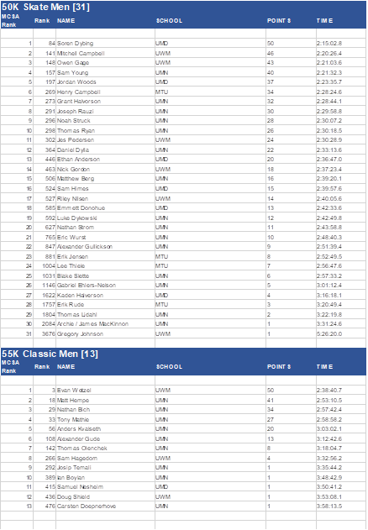
- Because of the difference in field sizes, a better position does not equal a higher score: (i.e. Anders Kvalseth was 5th in the Classic Discipline and scored 20 points; Henry Campbell was 6th in the Skate Discipline and scored 34 points). This reflects the variance in field size and strength in races with multiple disciplines.
Calculating Team Scores:
Below are the Team Scores from Men’s results at the 2020 American Birkebeiner.
- Remember – the five highest individual scores from each Team are added to form the Team Score. The highest Team Score wins.
- A Team can score with fewer than five skiers.

Calculating Overall Cup Scores:
Below are the Men’s Collegiate Cup scores for 2019-2020.
- Three events (the Half-Noque, Mt. Ashwabay Summit Race, and American Birkebeiner) comprised the 2019-2020 Collegiate Cup.
- Team Scores from all three events are totaled to form a team’s Cumulative Score. The team with the highest Cumulative Score wins the Collegiate Cup.
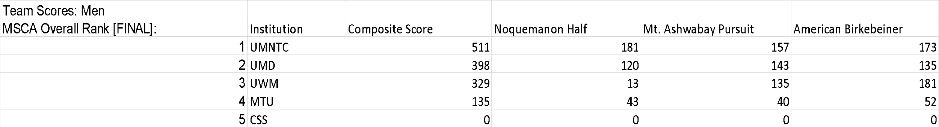
- REMEMBER: A rough performance, or even complete absence at Collegiate Cup event, will not prevent your team from doing well in the Collegiate Cup! Note that despite scoring only 13 points at the Half-Noque, UWM still finished in a podium spot on the Cup.

